H.T No
Regulations:
A15


Sreenidhi Institute of Science and Technology
(An Autonomous Institution)
Code No: 5K502 Date: 03-Dec-2018 (FN)

B.Tech III-Year I-Semester End External Examination, Nov/Dec - 2018 (Regular)
Structural Analysis - II (CIVIL)

Time: 3 Hours Max.Marks:75

Note: a) No additional answer sheets will be provided.
b) All sub-parts of a question must be answered at one place only, otherwise it will not be valued.
c) Missing data can be assumed suitably.

Part - A Max.Marks:25

Answer all QUESTIONS.

1. | What is the absolute bending moment when a single concentrated load rolls across the span? | [3M]
2. | Determine the horizontal thrust for a two- hinged parabolic arch of span ‘l’ is subjected to a uniformly distributed load of W/m. run over the whole span. | [3M]
3. | Write the temperature effect on cables. | [3M]
4. | Develop flexibility matrix for a beam AB of uniform cross-section with reference to the co-ordinates shown in fig. 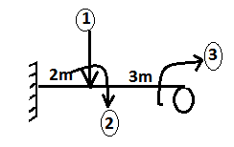 | [3M]
5. | Develop stiffness matrix for a portal frame ABCD of uniform cross-section shown in fig.  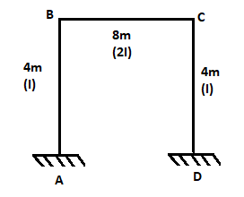 | [3M]
6. | Explain the relation between load factor and factor of safety. | [2M]
7. | What is the difference between three hinged arches and two hinged arches? | [2M]
8. | A cable carrying a load of 10KN per metre run of horizontal span, is stretched between supports 100 metres apart. The supports are at the same level and the central dip is 8metres. Find the greatest and the least tension in the cable. | [2M]
9. | Write stiffness matrix for a continuous beam ABC which is fixed at A and hinged at B&C, AB of span 4m is subjected to a point load of 25KN at 1m from A, BC of span 4m is subjected to a point load of 30KN at mid-span. | [2M]
10. | Define static and kinematic indeterminacy. | [2M]
Part – B Max.Marks:50
ANSWER ANY FIVE QUESTIONS. EACH QUESTION CARRIES 10 MARKS.

11. |  | Two wheel loads 80KN and 120KN spaced 4m apart roll on a girder of span 20m with 120KN load leading. Find the maximum bending moment at a section 8m from the right support. Draw bending moment diagram. | [10M]
12. |  | A three hinged parabolic arch ACB of span 30m and rise 8m carries a uniformly distributed load of 25KN/m over the left half of the span and two concentrated loads of 120KN each at distances 5m and 10m from B. Determine the bending moment, normal thrust and radial shear at a distance 15m from A. | [10M]
13. |  | A suspension bridge of 120m span has two hinged stiffening girders supported by two cables, having a central dip of 12m. The dead load on the bridge is 6KN/m² and the live load is 12KN/m² which covers the left half of the span. Determine the shear force and bending moment for the girder at 30m from the left end. Find also the maximum tension for this position of the load. The road way is 6m. | [10M]
14. |  | Analyze the continuous beam shown in fig. by flexibility method. Assume flexural rigidity is constant throughout.  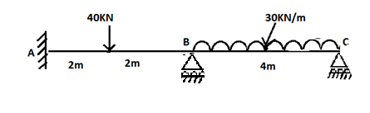 | [10M]
15. |  | Support ‘B’ of a continuous beam shown in fig. sinks by 2.5mm. Determine the final moments by displacement method. Take E=200KN/mm² and I=3.5X10⁷mm⁴  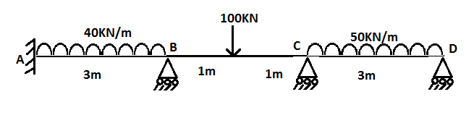 | [10M]
16. |  | Fig. shows a continuous beam of uniform section whose plastic moment of resistance is M_{p}. Find the value of W at collapse.  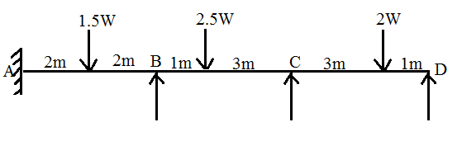 | [10M]
17. | a) | Write a short note on temperature effect of two hinged arches. | [5M]
 | b) | A three hinged arch of span 20m and rise 4m carries a uniformly distributed load of 25KN/m. find the horizontal thrust for the arch. If now the arch is subjected to a rise in temperature of 40⁰c, find what change in the horizontal thrust will occur. Take α=12X10⁻⁶ per⁰c. | [5M]
18. | a) | Define pratt and warren truss. | [2M]
 | b) | Analyze the frame shown in fig. by kani’s method. All members have same flexural rigidity.  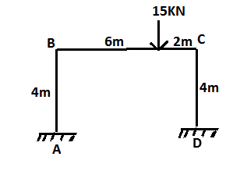 | [8M]
-- 00 -- 00 –

